Filed Pursuant to Rule 424(b)(3)

Registration No. 333-275229

PROSPECTUS SUPPLEMENT

(to Prospectus dated November 7, 2023)


Alpha Compute Corp

481,581 Ordinary Shares underlying Warrants

This prospectus supplement is being filed to update and supplement the information contained in the prospectus dated November 7, 2023 (the “Prospectus”), which forms a part of our Registration Statement on Form F-1 (Registration No. 333-275229), as amended most recently by the post-effective amendment filed on August 23, 2024, with the information contained in our current report on Form 6-K, furnished to the Securities and Exchange Commission on April 20, 2026 (the “April 20, 2026 Form 6-K”). Accordingly, we have attached the April 20, 2026 Form 6-K to this prospectus supplement.

This prospectus supplement updates and supplements the information in the Prospectus and is not complete without, and may not be delivered or utilized except in combination with, the Prospectus, including any amendments or supplements thereto. This prospectus supplement should be read in conjunction with the Prospectus, and if there is any inconsistency between the information in the Prospectus and this prospectus supplement, you should rely on the information in this prospectus supplement.

Our Ordinary Shares are listed on The Nasdaq Capital Market (“Nasdaq”) under the symbol “ALP”. On May 21, 2026, the closing sale price of our Ordinary Shares as reported on Nasdaq was $0.3852.

__________________________________

Investing in the securities offered in the Prospectus involves a high degree of risk. Before making any investment in these securities, you should consider carefully the risks and uncertainties in the section entitled “Risk Factors” beginning on page 9 of the Prospectus, and in the other documents that are incorporated by reference into the Prospectus.

Neither the Securities and Exchange Commission nor any state or non-U.S. regulatory body has approved or disapproved of the securities offered in the Prospectus or passed upon the accuracy or adequacy of the Prospectus or this prospectus supplement. Any representation to the contrary is a criminal offense.

__________________________________

The date of this prospectus supplement is May 22, 2026

UNITED STATES

SECURITIES AND EXCHANGE COMMISSION

Washington, D.C. 20549

FORM 6-K

REPORT OF FOREIGN PRIVATE ISSUER PURSUANT TO RULE 13a-16 OR 15d-16

UNDER THE SECURITIES EXCHANGE ACT OF 1934

For the month of April, 2026

Commission File Number: 001-40086

AlphaTON Capital Corp

(Translation of registrant’s name into English)

Clarence Thomas Building, P.O. Box 4649, Road Town, Tortola, British Virgin Islands, VG1110

(Address of principal executive office)

Indicate by check mark whether the registrant files or will file annual reports under cover of Form 20-F or Form 40-F.

Form 20-F [ X ] Form 40-F [ ]

INCORPORATION BY REFERENCE

This report on Form 6-K (including any exhibits attached hereto) shall be deemed to be incorporated by reference into the registration statements on Form S-8 (File Nos. 333-275842 and 333-289199) and Form F-3 (File Nos. 333-286961, 333-290827, 333-291341 and 333-291921) of AlphaTON Capital Corp (including any prospectuses forming a part of such registration statements) and to be a part thereof from the date on which this report is filed, to the extent not superseded by documents or reports subsequently filed or furnished.

On April 14, 2026, pursuant to prior approvals by our board of directors, we filed a Certificate of Change of Name and Amendment to our Memorandum and Articles of Association. The documents changed our corporate name from AlphaTON Capital Corp to Alpha Compute Corp to better reflect the nature of our expanded current business operations in compute and AI infrastructure.

On April 21, 2026, our shares of common stock will begin trading under the new symbol ALP on the Nasdaq Capital Market.

The Certificate of Change of Name and Amendment to our Memorandum and Articles of Association are filed as Exhibit 99.1 and Exhibit 99.2 to this current report and are incorporated herein by reference.

SIGNATURE

Pursuant to the requirements of the Securities Exchange Act of 1934, the registrant has duly caused this report to be signed on its behalf by the undersigned, thereunto duly authorized.

Date: April 20, 2026

ALPHATON CAPITAL CORP

By: | /s/ Brittany Kaiser
 | Brittany Kaiser
 | Chief Executive Officer

Exhibit 99.1
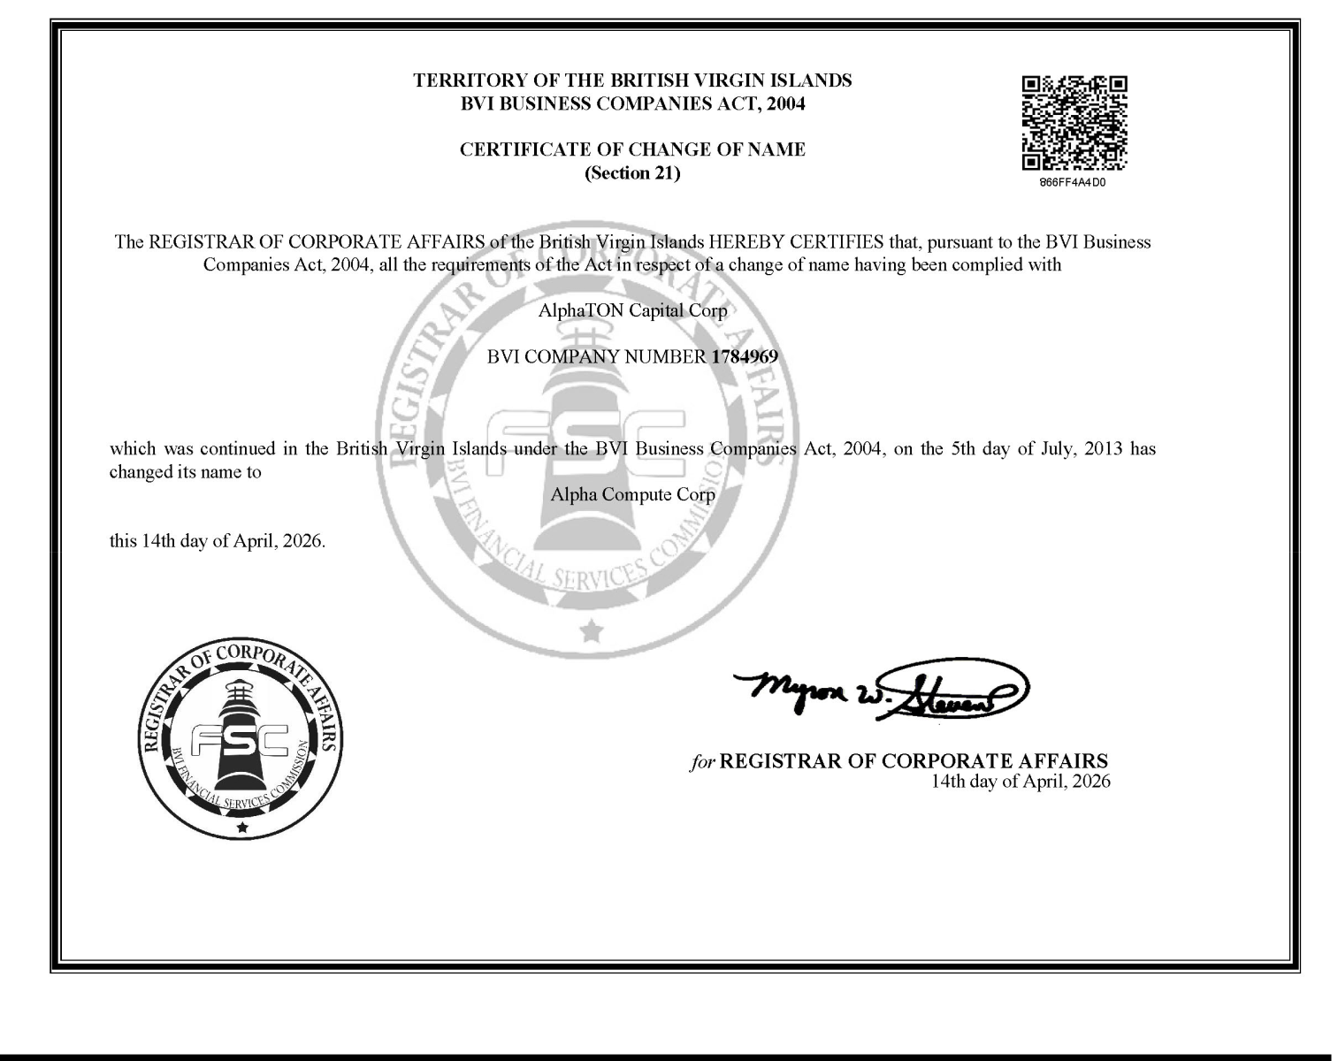

Exhibit 99.2


